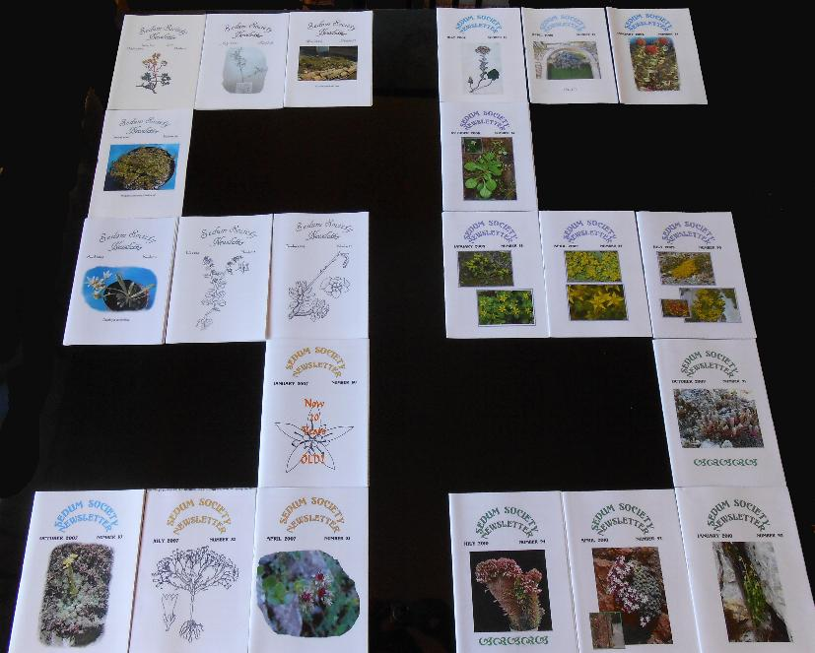
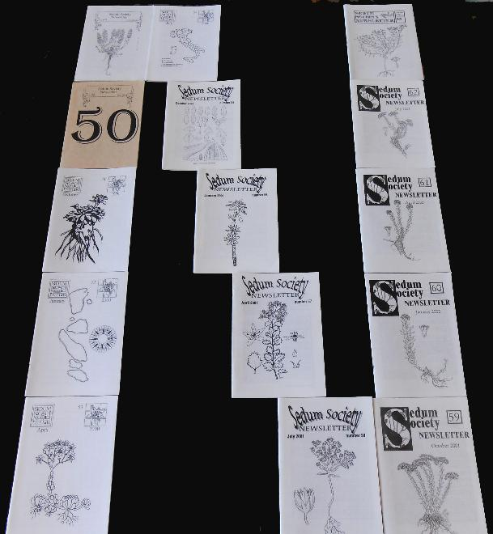
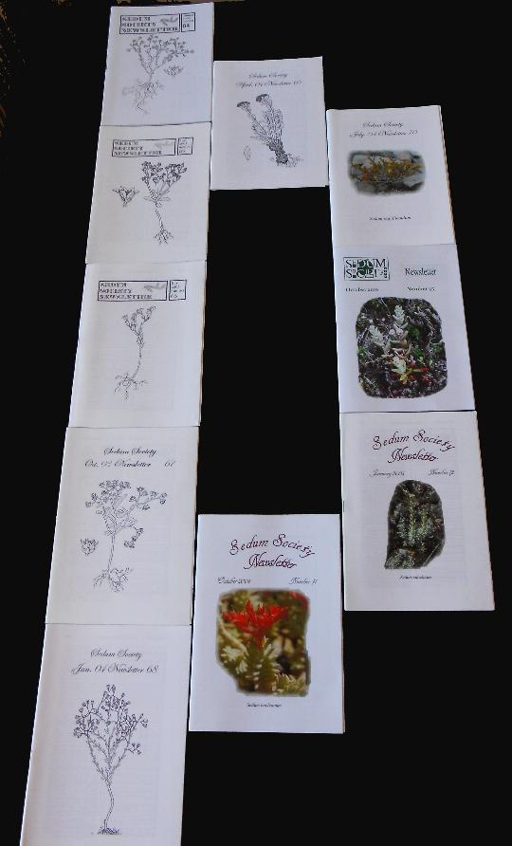
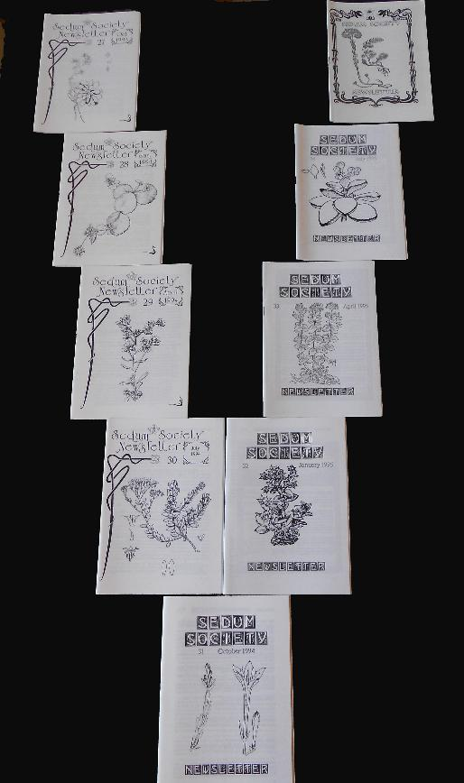
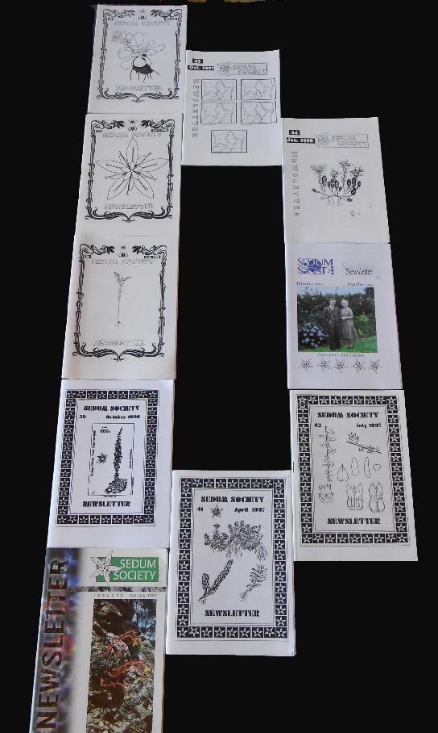

Back numbers of Newsletters are now available on DVD thanks to Marco Cristini.

DVD1 contains individual PDF files of Sedum Society Newsletters 1-50 (+ the same issues in blocks of ten and all Newsletters in a single block for easy search). PDF Xchange Viewer has a tool (OCR) that allows for the searching of words inside the Newsletters. The blocked issues may not work with versions of Windows earlier than XP but all others should be successful.
The disc also contains:
Index 1 - 100 by Frazer Henderson (PDF),
Previously unpublished photographs by Marco Cristini,
PDF files of the Front Covers

DVD2 contains individual PDF files of Sedum Society Newsletters 51-100 (+ the same issues in blocks of ten and all Newsletters in a single block for easy search). PDF Xchange Viewer has a tool (OCR) that allows for the searching of words inside the Newsletters. The blocked issues may not work with Windows earlier than XP.
The disc also contains:
Index 1 - 100 by Frazer Henderson (PDF),
Previously unpublished photographs by Marco Cristini,
PDF files of the Front Covers,
Gordon Rowley's 32-page succulents of the Herball or Generall Historie of Plantes by John Gerrard (as a Word file).

A. Berger's Sedum from Die natürlichen Pflanzenfamilien. A. Engler & K. Prantl, translated by R. L. Evans. Printed and distributed by The Sedum Society 2004; reset and edited by L. Springate & R. Stephenson into a 50+page booklet, translated by Ronald L. Evans (as a Word file).

